**CS2855 Databases**

**Part 2: ER Model  
ER Model** = high level data model

* collection of entities
* relationships
* constraints
* attributes

**Entities: thing**

* have attributes
* entity set = set of entities of same type, same kind of attributes
* entity has value for each attributes

**Relationship: association among several entities**

* Relationship-set = set of tuples (relationships) Role: function that an entity plays in a R  
  E.g. **R** = Joan is father of Sean. **E** = Joan, Sean. **Role:** parent-child relationship. Can have 2 roles

**Descriptive attribute**: an attribute of a relationship set

**Degree** = no. of entity sets in relationship set

* binary = 2
* ternary = 3

**Attributes** = properties  
**Domain** = set of permitted values for each attr  
Attribute of an entity = a function that maps entity set onto a domain  
entity = set of pairs (attribute, data value)

**Types of Attributes**

* Simple, Composite attributes
* Single-valued, Multi-valued attributes
* Derived attributes (computed from other attr

**Constraints**

**M**apping cardinalities

* no of entities to which another entity can be associated via a relationship set
* binary = 1 to 1, 1 to *, * to 1, * to *

**Ternary Relationships**

* only 1 arrow out of a ternary relationship
* if > 1 = confusing

A ternary relationship *R* between *A*, *B* and *C* with arrows to *B* and *C* could mean  
1. Each *A* entity is associated with a unique entity from both *B* and *C ; or*  
2. Each pair of entities from (*A, B*) is associated with a unique *C* entity, and each pair (A, C) is associated with a unique B

**Keys**

* Differences= in the attributes
* how entities & relationships are distinguished
* key = allow us to distinguish them
* **Super Key** = set of one/more attr sufficient to uniquely determine an entity
* **Candidate key** = minimal super key
* **Primary key** = candidate key chosen
* **Foreign Key** = an attr corresponds to the primary key of another relation scheme

*Super Key for relationships =   
PrimaryKey(E1) U PrimaryKey(E2)  
**Participation constraints**

* Participation of an entity set = total (if every entity in E participates in at least one relationship in R)
* or else = partial

**Roles**

* labelling lines that connects diamonds to rectangle
* (optional) clarification (e.g, manager, worker)

**Design Issues**

* Use of entity sets VS attributes (enterprise)
* Use of entity sets VS relationship sets (use R, if an action occurs between entities)
* Binary VS n-nary relationship sets (if n-nary is more clear, than several binary, partial info)
* Placement of relationship attributes
* Mapping Cardinalities (access-date can be attribute of acc if each account can have only one customer)

**Weak Entity Sets**

* no primary key
* existence = depends on existence of identifying entity set
* **discriminator/partial key** = super key of a weak entity set
* primary key = (primary K of strong set) + partial K
* more appropriate as an attribute if participates in only identifying relationship, and has few attribute (multivalued composite attribute)

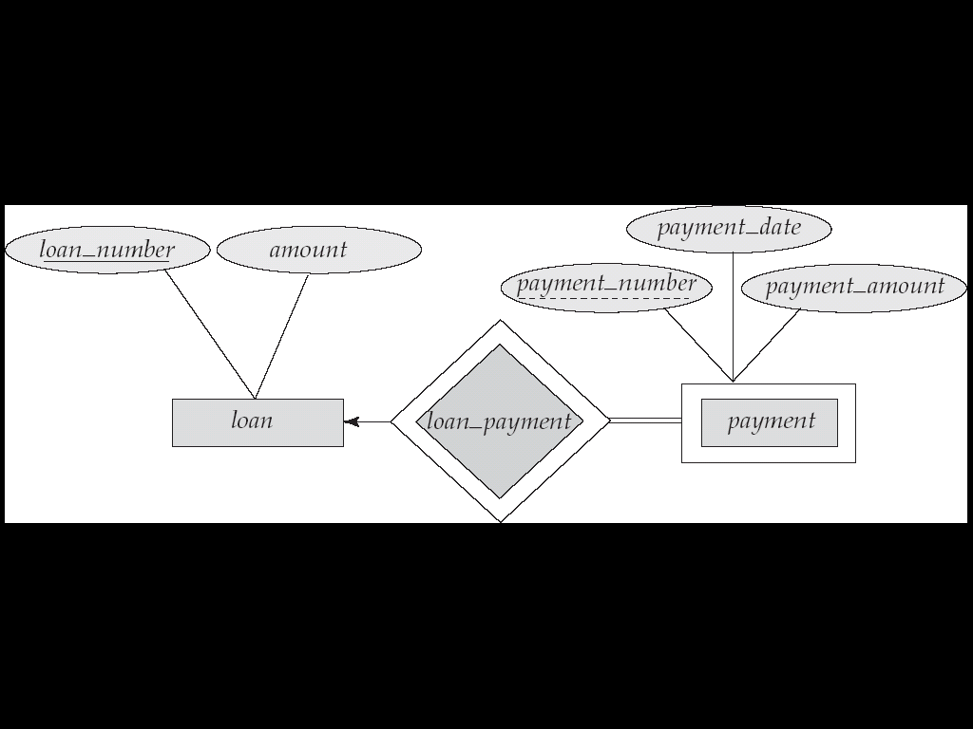

**Specialization**

* attribute inheritance (lower level inherits attribute + relationship of higher level)

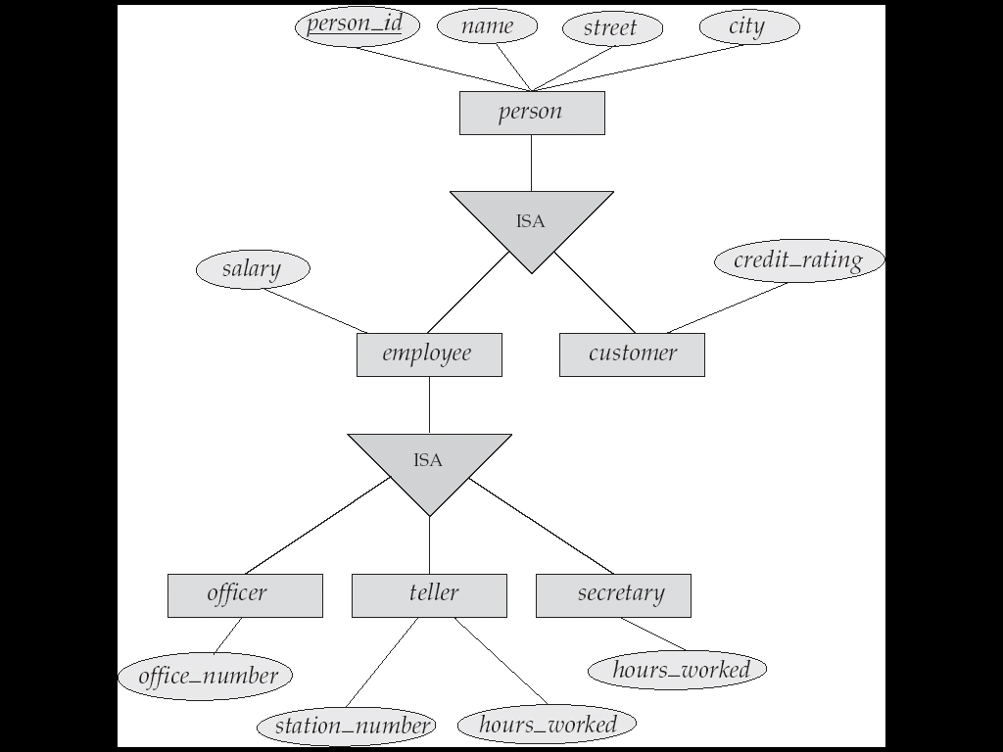

**Generalization**

Opposite of Specialization

* + - 1. Constraints be members of lower level
      2. Constraints on belong to more than one lower level
         1. Disjoint – 1 lower-level
         2. Overlapping – more than 1 lower-level
      3. Completeness Constraint
         1. Total = must belong to one of the lower level
         2. Partial = need not belong to…

**Aggregation**

* eliminate redundancy
* treat relationship as an abstract new entity
* allow relationships between relationship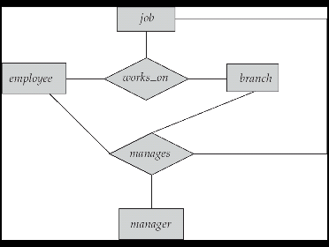 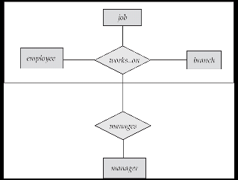

**Shapes**

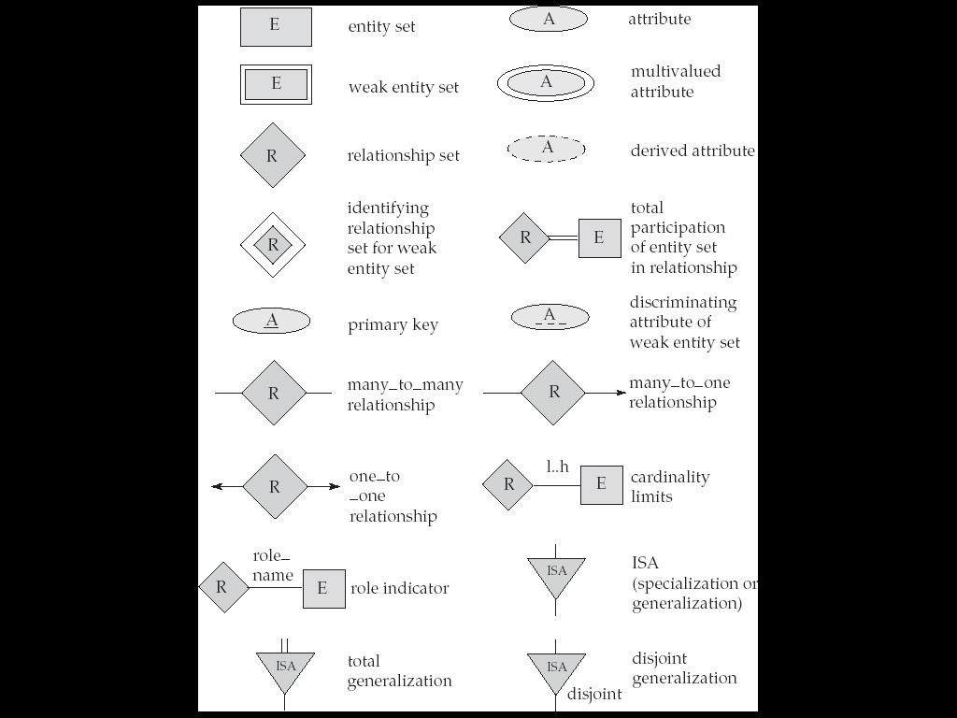

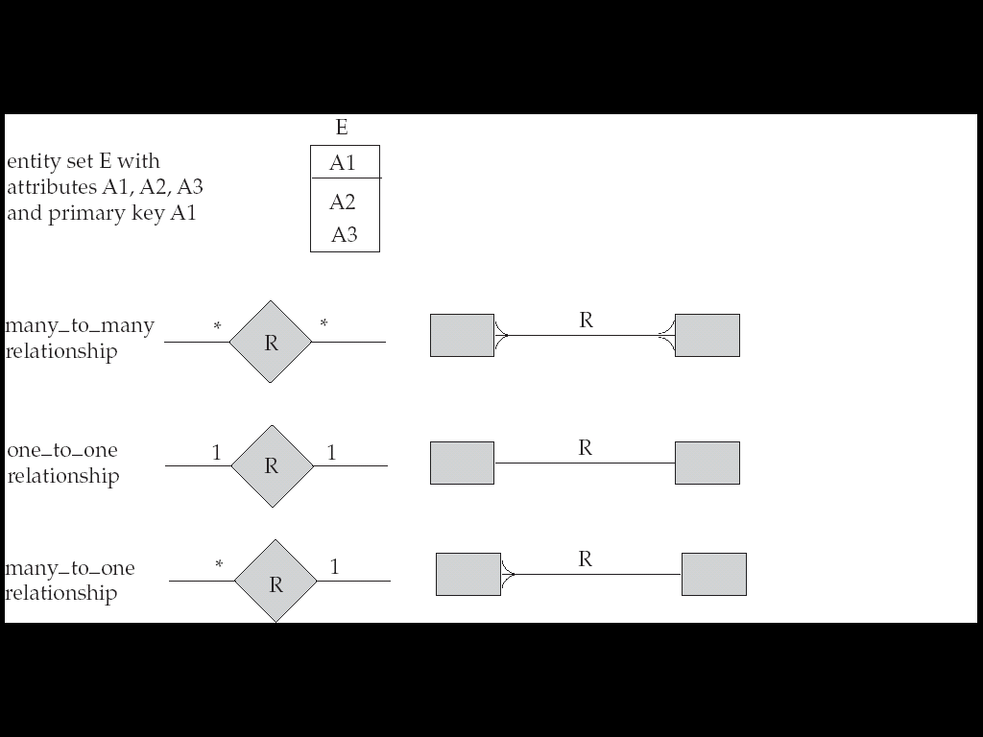

**Relational Model**

Conceptual Design of Database

* Relation
* Relation Schema
* Relation instance
* Key
* Schema Diagrams

Transform ERD to Relational Model

Relational Algebra = specify request for info

**Structure of Relational Model**

Consists of collection of tables (unique name)

Row in table = relationship among set of value

Headers = attributes

Permitted values = domain

Relation *R*  is a subset of D1 x D2 x D3

Relation is a set of n-tupes (a1, a2, .. , an) where ai E Di

**Attribute**

Each attribute of a relation has name

Allowed values of attribute = domain of attribute

Should be atomic (indivisible, cannot be broken down)

*Therefore domain is atomic if members are atomic

Special value *NULL* = member of every domain

**Relation Schema** = list of attributes *like type

Cus_schema= (cus_name, cus_street, cus_city) *like var

**Relation**  on the relation schema **R =** r(R)

Customer(cus_schema)

**Relation instance** = current value *like value of var

Element t of r is a tuple(row)

**Order of tuples** = irrelevant

**Normalization Theory**

Info = broken into parts, each relation storing one part

Store all info into one single relation = repetition of info

**Foreign Keys**

**Convert ERD to relational Schemas**

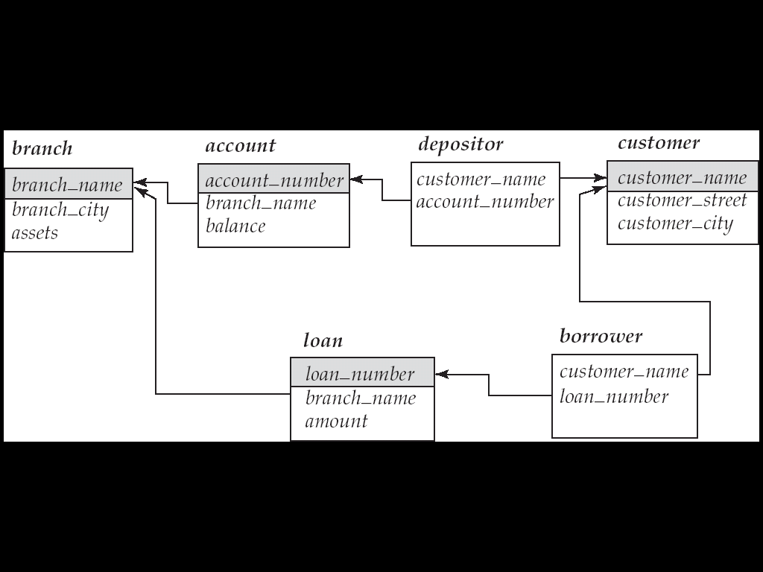

Database = can be represented by collection of schemas

Each Entity and Relationship = relation schema

Constraints (From ERD) mapped to relation schemas

**Representation of Strong Entity Set**

E with n distinct attributes (PK is the same PK)  
*E.g. loan = (loan_number, amount )*  
**Representation of Weak Entity Set**

E = {a1, a2, am} U { b1, b2, bn}

PK = PK of strong + discriminator of

FK = PK of strong

*E.g. loan = (loan_number, payment_number, payment_date, payment_amount )*

**Representation of relationship set**

R = {a1, a2, am} U { b1, b2, bn}

a and b = descriptive for relation  
R formed by union of primary of both sets

*..* = PKa U PKb

1..1 = PKa OR PKb

1..* = PK*

*..*..* = PKa U PKb U PKc

1..*..* = PK*

**Combination of Schemas**

If TOTAL participation of A, then can combine A to AB into 1 schema

If 1..1, then can combine also

**Redundancy of Schemas**

R for weak to strong = no need to be present

**Composite Attributes**

Sub-Attr = flattened out, no separate attr for composite

**Multi-valued Attribute**

Create new schema for the MV Attribute with PK of the E  
MV Attr = (PKE, MV_value)

**Representing Specialization via Schema**

**Method 1:***person = (person_id, street, city)   
customer = (person_id, credit_rating)  
employee = (person_id, salary)*

**Method 2: (**disjoint + total) *employee = (person_id, name, street, city, salary)*

*customer = (person_id, name, street, city, credit_rating)*X = if there is R with the higher level entity set

**Relational Algebra**

QL = user request info from DB

* Procedural (Relational algebra)
* Non-procedural

6 basic operators

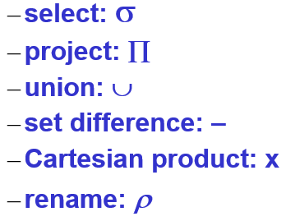

**SELECT**

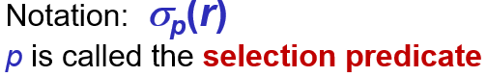

p = formula which have:

* ^and, Vor, =, >, <

**PROJECT**

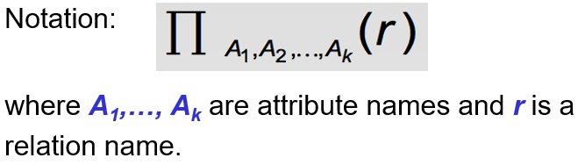

= show rows listed, and no duplicates

*Duplicate rows are removed

**UNION**



R and S must be compatible:

* R, S same arity
* Attribute domains = compatible

**SET DIFFERENCE**



R and S must be compatible:

* R, S same arity
* Attribute domains = compatible

**CARTESIAN-PRODUCT**

Notation *r* x *s*

R and S = disjoint (if not, use dot borrower.name)

**COMPOSITION of Ops**

Can do nested operations 

**RENAME Ops**



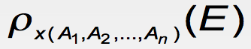

Name of attributes changed to A1, A2, An

**Set-Intersection Op**



R and S must be compatible:

* R, S same arity
* Attribute domains = compatible

**Natural-Join Op**

1. Forms a Cartesian product

2. Performs a selection, forcing equality between values  
3. Remove duplicate attributes

**Division Ops *r* ÷ *s***

Values of attribute A appear in r with every possible value of B in s

**Assignment Op 🡪**

Provides a convenient way to express complex queries

**Null**

Null = unknown or value does not exist

Null = null (in SQL)

Modification of the Database

Deletion

* Selected tuples are removed
* Can only delete tuples (not values)
* r <- r - E

Insertion

* r <= r U E

Updating

* 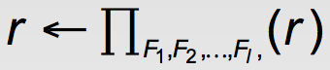

**SQL**

* Define structure of data
* Modify data
* Security constraints

**DDL and Interactive DML**

* Schema
* Domain
* Integrity constraints
* Security and authorization
* Physical storage structure

Data Definition

Domain Types

* Char, varchar, int, float

Create Table

* *Create table r (A1 D1,… (integrity cconstraint1))*

Drop/Alter Table

* Alter table r add A D

*Select (distinct) * from loan as L where L.name=’mary’ and amount>1200 or L.name like ‘%hel&’ order by L.name asc*

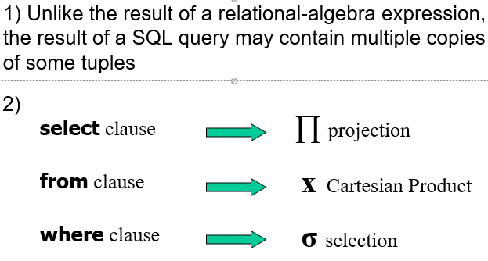

Set Operation

* Auto remove duplicates
* *Union, intersect, except*

Aggregate functions

* *Avg, min, max, sum, count*
* Can use with *groupby, having*

Null Values

* *Is null, is not null*
* Ignores null values if using *count(*)*

3 logic *= True/false/unknown*

Result of *where* is *false* (if *unknown*)

Set membership

* *In, not in*

Set comparison

* *Some, all*
* *Greater than at least one = >some*

Derived Relations

* Subquery expression used in the *from* clause
* 2 froms

With clause

* Temporary view
* Used to simply derived relations

Views

* Any relation not of the conceptual model made visible to user as virtual relation = view
* Use to hide certain data
* Create view v as <query>
* Stored the definition (not results)

View Expansion

* Not recursive, loop will terminate.

Database Modification

* Delete (will compute and select the ones to delete, and delete. Avg won’t be recomputed)
* *Insert*
* *Update* (order is important)

Case statement

* *Update account*

*Set balance = case*

*When balance <=10000*

*Then balance *1.05*else balance * 1.06

End

Update with Views

* Difficulty: a modification to db in terms of view  
  Therefore modifications not permitted on view
* Updatable : sql which modifications are allowed

Built in Data Types

* Date (year, month, date)
* Time (hours minute seconds)
* Timestamp (date plus time)
* Interval (period of time)

Can extract values from it (year from date)

Can cast string to date/time/timestamp

Allow comparisons

User-defined Types

* helpful for avoiding errors
* *Create type Dollars, as numeric (12,2) final*
  + *Final* cannot have subtype
* Cannot assign or compare (different types)
* Can cast
* Drop Type and Alter Type

User-defined Domains

* Most elementary form of integrity constraint
* Test value when inserted
* *create domain Dollars numeric (12,2)*

Large-Object Type

* blob: binary large object
* clob: character large object
* returns pointer to large object

Integrity Constraints

* Guard against accidental damage to db.
* Not null
* Primary key, foreign key
* Unique
* Check (P, where P is a predicate)
  + Check in the create domain
  + *create domain Dollars numeric (12,2)*

constraint value_test check (value> = 4.00)

* can be added by using alter

alter table table_name add constraint

Referential Integrity

* foreign key
* value must appear as a tuple in another table
* *foreign key (branch_name) references branch*

Assertion

* a predicate, P, that db must always satisfy

*create assertion assertion_name check predicate*

* checks on every update (might have great overhead)

Authorization

* Privileges
* Select, Insert, Update, Delete,
* Resources (new relations),   
  alteration (add/rm attributes),   
  drop (delete relations) <- schema
* All privileges
* Using GRANT/REVOKE  
  grant privilege-list on relation-name to userlist
* Grant view =/= grant underlying relations
* Grantor must have priv himself
* REVOKE can be on all except those allowed explicitly
* If granted twice, one revoke, still can access
* All privileges dependent on another privilege (will be revoked tgt)

Stored Procedures

* Ifelse, for, while
* Execute them using **call** statement

SQL functions

* Allows overloading (diff arg loaded)
* Allows return of table
* Written as procedure as well

Procedural Constructs

* While and repeat, for loop
* Begin … end

External Language Routinesa

* More efficient for many ops,

Security concerns

* Code to implement function needed to be loaded in db and exec in DB system
  + Accidental correction
  + Security risk (user can access unauthorized data)
* Alternatives = good security , bad perf

Sandbox or Run external language in separate process (no access to DB memory, talk via IPC)

* Performance overhead

**Relational DB**

* Without unnecessary redundancy, retrieve info
* Functional Dependencies (normal form)
* Spilt tables (decompose)
* Combine tables = repetition of information
* Rule, functional dependency

**Lossy Decomposition**

* Lose info, cannot reconstruct original relation

**Good Form**

* Decompose everything into good form
* Lossless-join decomposition
* **Based on:**
  + Functional dependencies
  + Multivalued dependencies

**Functional Dependencies**

* Constraints on set of lega l relations
* Notion of key (uniquely identify tuple)

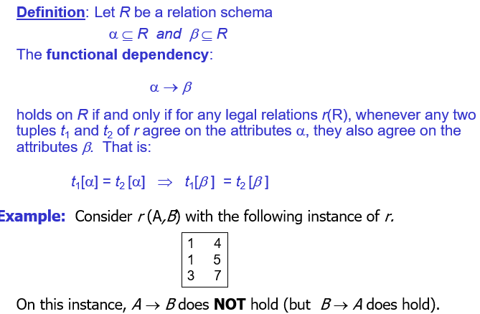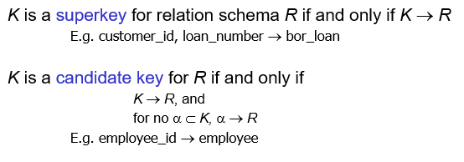

* express constraints on the values of attributes  
  (that cannot be expressed using superkeys)
* allow us to generalize how relations should satisfy certain properties

Loan_number -> amount = (good)

Amount-> customer_name = (wrong)

**Used for:**

* Test relations (legal, given set of functional dependencies)
* Specify constraints (on set of legal relations)

*smt might turn out to be ok, but not legal  
 (amount->cust_name)

**Closure & Canonical**

Closure = set of ALL functional dependencies logically implied by F is the CLOSURE of F

Closure of F = F+

F+ is a superset of F

**Armstrong’s Axioms**

if *β* ⊆ α, then α → *β* (reflexivity)

if α → *β,* then γ α → γ *β* (augmentation)

if α → *β,* and *β* → γ, then α → γ (transitivity)

**Sound:** generate only functional dependencies that hold

**Complete:** generate all functional dependencies that hold

To compute:

*F* + = *F*  
**repeat**  
 **for each** functional dependency *f* in *F*+  apply reflexivity and augmentation rules on *f* add resulting functional dependencies to *F* + **for each** pair of functional dependencies *f*1and *f*2 in *F* +  **if** *f*1 and *f*2 can be combined using transitivity  
 **then** add the resulting functional dependency to *F* +**until** *F* + does not change any further

**Extraneous Attributes**

Attribute = extraneous if can be removed without changing closure of set of functional dependencies

**Canonical Cover**

Set of FD may have redundant D that can be inferred from others

= minimal set of FD equivalent to F, having no redundant dependencies or redundant parts of dependencies

A ***canonical cover***for *F* is a set of dependencies *Fc* such that

* *F* logically implies all dependencies in *Fc,* and
* *Fc*logically implies all dependencies in *F,* and
* No functional dependency in *Fc* contains an extraneous attribute, and
* Each left side of functional dependency in *Fc* is unique.

Compute:

Fc = F;

**repeat** Use union rule to replace any dependencies in *Fc* α1 → β1 and α1 → β2 with α1 → β1 β2   
 Find a functional dependency α → β in *Fc* with an   
 extraneous attribute either in α or in β   
 If an extraneous attribute is found, delete it from α → β  
**until** *Fc* does not change

**Normalization**

Processing of organizing data to minimize redundancy

TO AVOID

* **Insertion anomalies** (check consistency of info when inserting data)
* **Deletion anomalies** (info may lost as a result of deleting last tuple)
* **Update anomalies** (updates is consistent)

**1st Normal Form**

* Domain is atomic (indivisible)

**Boyce-Codd Normal Form (BCNF)**

* For all functional dependencies
  + α → *β* is trivial (i.e., *β* ⊆ α)
  + α is a superkey for *R*

**BCNF and Dependency Preservation**

All FD holds, decomposition = dependency preservation

No schema that includes all attributes appearing in this functional dependency. = not dependency preserving

**3rd Normal Form**

* For all functional dependencies
  + α → *β* is trivial (i.e., *β* ⊆ α)
  + α is a superkey for *R*
  + Each attribute *A* in *β* – α is contained in a candidate key for *R.*
* *If in BCNF, it is also in 3rdNF*

**Differences of 3NF and BCNF**

3NF

* Decomposition = lossless
* Dependencies preserved

BCNF

* Decomposition = lossless
* May not be possible to preserve dependencies

Goals:

* BCNF
* Decomposition = lossless
* Preferably, should be dependency preserving

If cannot then accept:

* Lack of dependency preserving
* Redundancy due to 3NF

*Doesn’t work in SQL

Lossless decomposition

= satisfies all the functional dependencies:  


R generated when converting ER diagram to set of tables

R single relation, normalisation due to break into smaller relations

R = result of some adhoc design of relations, then convert to NF

ER carefully designed = no need further normalization

Can denormalize for performance.

**Transactions**

= unit of program execution that accesses and possibly updates various data items

2 main issues = failures, concurrent execution

**Requirements**

1. **Atomicity Req =** partial executed transactions should not be reflected
2. **Durability =** Updates to the DB must persist
3. **Consistency** = includes :  
   **-**specified integrity constraints (PK and FK)

**-**implicit integrity constraints

Preserves consistency of db

1. **Isolation =** executed in a serial manner (even when multiple transaction)